

April 26th, 2024

PLANNING AND PROGRESS REPORT

**Repository: https://github.com/C1-010/Acme-SF-D03**

Group: C1.010

García Rivero, Andrés - [andgarriv@alum.us.es](mailto:andgarriv@alum.us.es)

López Cubiles, Antonio José - [antlopcub@alum.us.es](mailto:antlopcub@alum.us.es)

Nieto Vicioso, Javier - [javnievic@alum.us.es](mailto:javnievic@alum.us.es)

Díaz Ordoñez, Pablo -  [pabdiaord@alum.us.es](mailto:%20pabdiaord@alum.us.es)

Sevillano Barea, Alejandro - [alesevbar@alum.us.es](mailto:alesevbar@alum.us.es)

Content Table

1. Executive Summary 2

2. Revision Table 2

3. Introduction 2

4. Contents 2

5. Conclusions 2

6. Bibliography 2

# 1. Executive Summary

# This report provides a comprehensive overview of my progress and activities during the project's development in this deliverable. Key tasks undertaken include setting up the development environment and implementing the initial mandatory functional requirement. Despite encountering challenges such as extended installation times, satisfactory progress was achieved. Tasks were completed within the designated timeframe, with documentation provided through screenshots. Additionally, a budget was estimated, considering work hours and associated costs. The report aims to outline the progress made and establish a foundation for future project iterations. The document structure includes detailed planning, progress tracking, and conclusions drawn from this milestone execution.

# 2. Revision Table

|  |  |  |
| --- | --- | --- |
| Revision number | Date | Description |
| 1 | [26/04/2024] | Beginning of the report. All sections completed. |
| 2 |  |  |

# 3. Introduction

This report offers a detailed insight into my progress and planning efforts throughout the project's development. During this period, I undertook critical tasks to establish the necessary work environment and implement the initial mandatory functional requirement.

Despite encountering challenges, such as longer than expected installation times, I managed to make satisfactory progress. Tasks were allocated and completed within the designated timeframe, with screenshots recorded to document delivery statuses at various development stages.

Additionally, I estimated a budget considering work hours and associated costs. The aim of this report is to provide an overview of the progress achieved to date and establish a solid foundation for future iterations of the project.

Furthermore, the document structure includes a detailed description of the planning conducted, progress made, and conclusions drawn from this milestone execution.

# 4. Contents

4.1 Planning

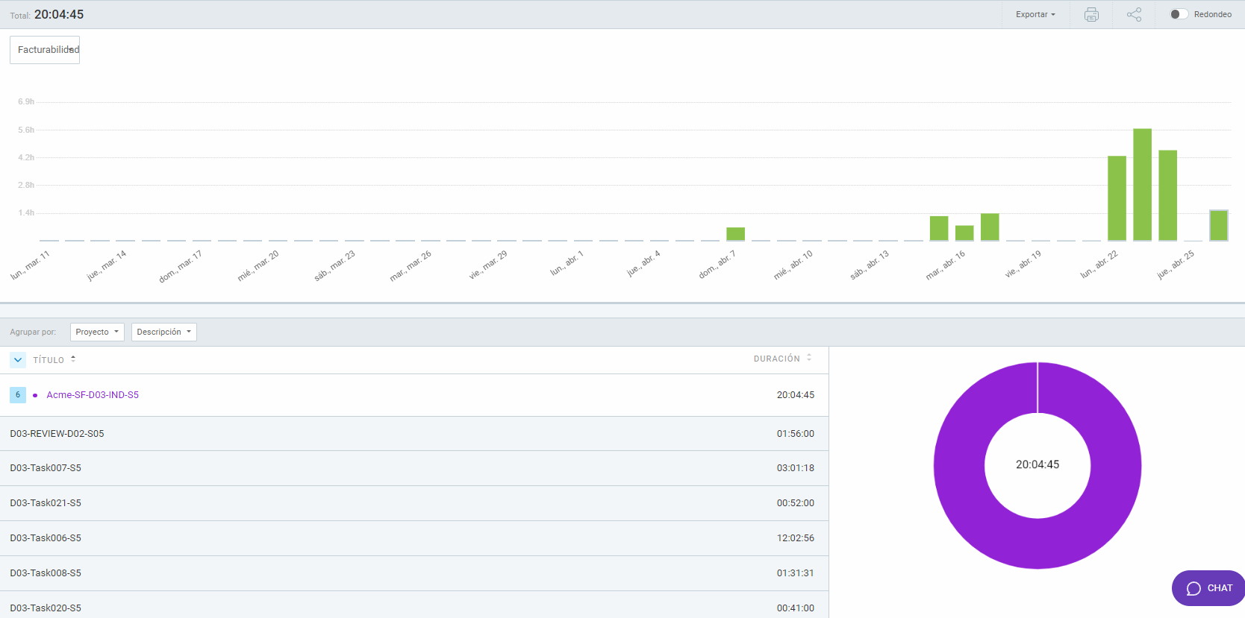

**Screenshots**

Initial screenshot of tasks in the “to do” status:

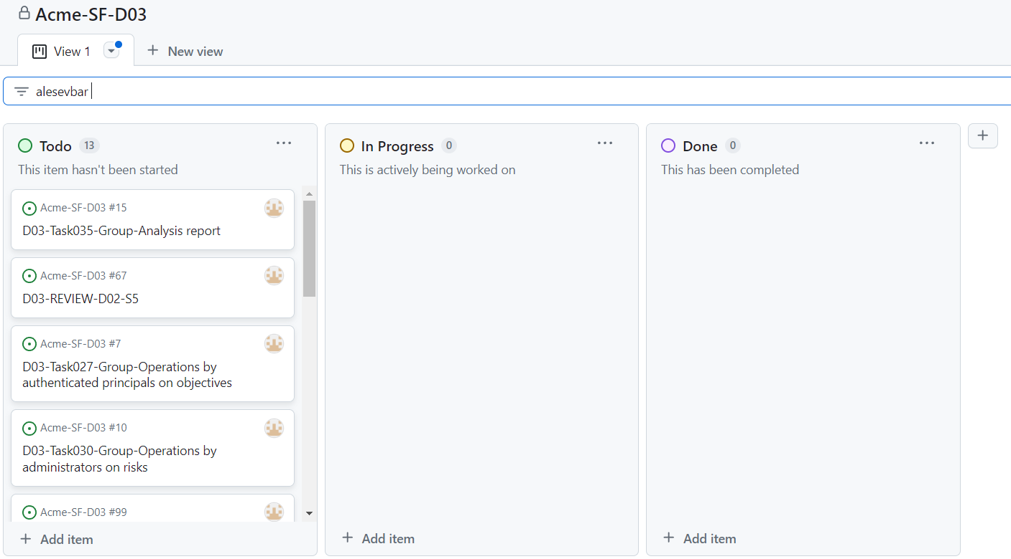

Intermediate screenshot of tasks in the process to be completed:

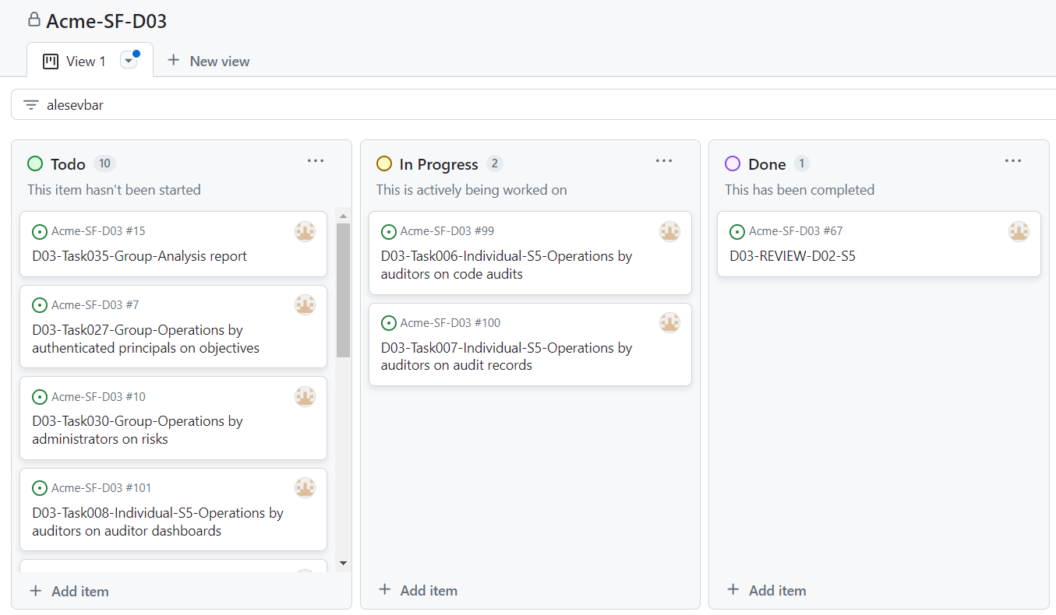

Screenshot at the end of the deliverable :

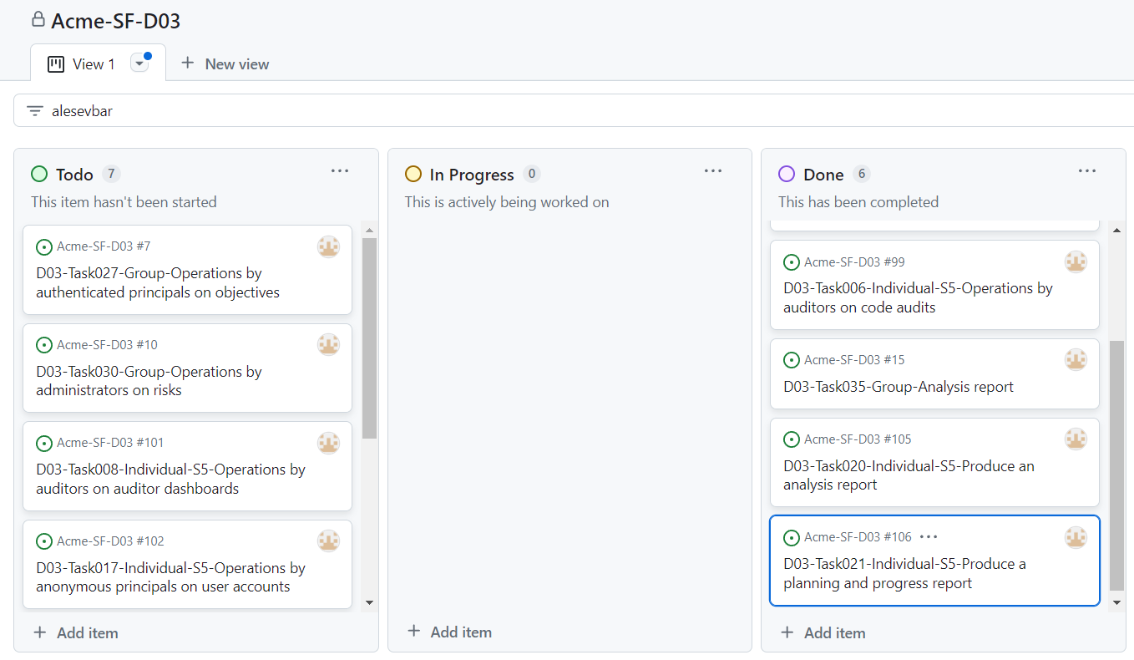

**Budget:**

**Breakdown by tasks**

|  |  |  |  |  |  |  |
| --- | --- | --- | --- | --- | --- | --- |
| **Task** | **Role** | **Salary per minute** | **Estimated time (minutes)** | **Estimated Cost (€)** | **Real Time(minutes)** | **Real Cost (€)** |
| Review-D02 | Analyst | 0,5 | 120 | 39,6 | 116 | 58 |
| Task-006 | Developer | 0,33 | 240 | 79,2 | 722 | 238,26 |
| Task-007 | Developer | 0,33 | 240 | 79,2 | 181 | 59,73 |
| Task-008 | Developer | 0,33 | 180 | 59,4 | 91 | 30,03 |
| Task-020 | Analyst | 0,5 | 60 | 30 | 41 | 20,5 |
| Task-021 | Analyst | 0,5 | 150 | 75 | 52 | 26 |
| TOTAL |  |  | 990 | 441,6 | 1203 | 432,52 |

4.2 Progress

**Progress Record:**

|  |  |  |
| --- | --- | --- |
| **Member** | **Performance** | **Action Taken** |
| López Cubiles, Antonio José | Punctuality and quality - Bad | Does not apply |
| García Rivero, Andrés | Punctuality and quality - Bad | Does not apply |
| Díaz Ordoñez, Pablo | Punctuality and quality - Excellent | Does not apply |
| Nieto Vicioso, Javier | Punctuality and quality - Excellent | Does not apply |

**Conflict and Resolution:**

Intentionally blank.

# 5. Conclusions

The development phase of the project has brought significant progress although there are mandatory tasks such as 08 that are not yet completed. Of the supplementary tasks this time I have only done the Analysis report and Planning and progress report.

I consistently completed more than 60% but less than 90% of assigned tasks within the specified time frame.

Although actual costs varied slightly from estimates, they remained close. This underlines the importance of precise planning.

# 6. Bibliography

Intentionally blank.